1. **Basic Information**
   1. Course: CS-6630 Visualization for Data Science - Fall 2023
   2. Title: **A Star is Born: Visualizing Stellar Evolution**
   3. Group Members:
      1. Rebecca Corley (u6036055)  
         [u6036055@utah.edu](mailto:u6036055@utah.edu)
      2. Kevin Mooers (u00600332)

u00600332@utah.edu

* 1. Link to project repository:
     1. <https://github.com/dataviscourse2023/final-project-too_old.git>

1. **Background and Motivation**

We initially prepared to work on a project incorporating climate data. After scrolling through previous works, we challenged ourselves to brainstorm a more original project. We selected this project based on a combined interest in astronomy/astrophysics and the fact that at least one member of the group actively works on particle astrophysics research in their graduate work. Through this project, we hope to become more familiar with stellar evolution as well as learn visualization techniques.

Stellar evolution is the process by which a star changes throughout its lifetime. The lifetime of a star is dictated by the mass of a star. More massive stars can have lifetimes of around a few million years, whereas smaller stars can live on the order of trillions of years. All stars begin their lives from a gravitational collapse of giant molecular clouds of gas and dust. These molecular clouds are often referred to as nebulae. Stars like these, still in their early stages of gathering gas and dust, are called protostars. Over the next millions of years, protostars gradually reach a state of equilibrium, becoming main-sequence stars.

For a majority of its lifespan, a star derives its energy from nuclear fusion. Initially, this energy results from the fusion of hydrogen atoms within the core of main-sequence stars. As the core accumulates more helium, stars (like our Sun) transition to fusing hydrogen in a spherical layer surrounding the core. As this process progresses, it leads to a gradual increase in a star’s size, where it passes through the next stage of its life: the subgiant phase. Subgiant stars continue to accumulate mass into the red giant phase.

Stars with at least half the mass of the Sun can also produce energy by using helium in their core, while more massive stars undergo fusion of heavier elements across concentric shells. When a star akin to the Sun exhausts its nuclear fuel, its core collapses into a dense white dwarf, and the outer layers are ejected, forming a planetary nebula.

Stars with roughly ten times the mass of the Sun (or more) can undergo a supernova explosion when their inert iron cores collapse, resulting in the formation of an incredibly dense neutron star or black hole. Although the universe has not yet witnessed the end of the lifespan of the smallest red dwarfs, stellar models predict that they will gradually become brighter and hotter before depleting their hydrogen fuel and evolving into low-mass white dwarfs.

The HR Diagram, as seen in **Figure 1**, is an important tool for understanding stellar evolution. This plot shows the luminosity vs absolute temperature of stars. As a star goes through changes in its lifecycle, it follows a characteristic path moving to different regions of the HR diagram, which is dependent on the chemical composition and mass of the star. In this work, we propose to create an interactive visualization of the HR diagram for users to better understand stellar evolution.

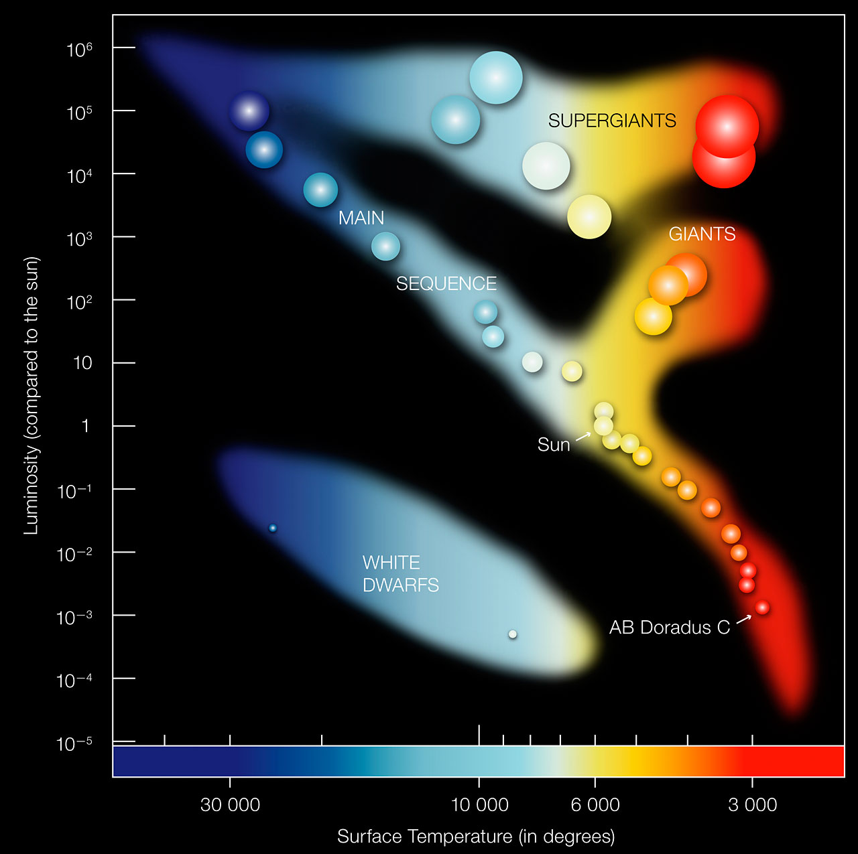

**Figure 1:** Example of a Hertzsprung-Russell diagram, which depicts the life cycle of stars. Credit: ESO

1. **Project Objectives**

In this work, we will design interactive stellar evolution models. The visualizations will explain how a star changes through its lifetime. One of our main visuals will be a dynamic tree that branches off into different stages of a star’s life. The initial part of a star’s life cycle, protostar phase, during which a star gathers its mass, plays a crucial role in shaping the star's future evolution. Due to variations in the masses stars accumulate during their early stages, they undergo diverse life cycles, and we can create different branches of the stellar evolution tree for users to follow and learn. We also plan to incorporate a sliding timeline that users can adjust. As a user moves the timeline, stars will move through paths on the HR diagram depicting how they evolve through time.

From a visualization learning standpoint we want to become comfortable loading data into a webpage, use D3 to construct dynamic charts and graphs, and attempt to apply more sophisticated visual techniques, transitions, and annotations to our visualizations. Additionally, we will learn how to use JavaScript, particularly the D3 library, HTML, and CSS.

Informing and educating the public about stellar phenomena is an important step in building engagement and funding for astronomical projects. The study of astronomy has implications for our understanding of the universe. Lastly, encouraging public engagement furthers support from funding agencies for development of technologies that can improve life on earth.

1. **Data**

We will use stellar data acquired from Gaia. Gaia is a space telescope run by the European Space Agency (ESA) that measures position, distance, and motion of stars with extraordinary precision. It is a global astronomy mission, working to catalog the largest, most precise picture of our galaxy. We will make use of their second released catalog, as it is the most detailed to date. Below are links to the Gaia archive and Gaia HR diagram, which was created using more than four million stars from the Gaia catalog.

* [**Gaia archive**](https://gea.esac.esa.int/archive/)
* [**Gaia HR diagram**](https://sci.esa.int/web/gaia/-/60198-gaia-hertzsprung-russell-diagram)

1. **Data Processing**

Gaia provides raw data files in a CSV format and has a data-tool where users can submit [ADQL queries](https://www.cosmos.esa.int/web/gaia-users/archive/writing-queries) to fetch and merge data. We do not anticipate significant data cleaning will be necessary, but we will need to read and understand the documentation to be clear about which data we are fetching. From the Gaia data, we will use stellar properties including: temperature, mass, radius, spectral class, luminosity, and absolute magnitude. From these variables, we can then derive others, such as color. We can use different combinations of these variables in our visualizations.

We will have to consider the volume of data available. It may not be feasible to load *every* observed object from the Gaia dataset into the visualizations we propose, nor would it be useful to the viewer. Instead, we may take a subset of the data, which will be determined as we progress through the project timeline.

1. **Visualization Design**

In setting out to do this project, we looked at examples of how astronomical data is presented for inspiration. We found [Aaron Geller from Northwestern University](https://faculty.wcas.northwestern.edu/aaron-geller/visuals.html) particularly inspiring. He has produced a number of top-tier astronomical data visualizations. Although many of these attempt to illustrate events in three-dimensional space (we feel this would be out-of-scope for our first project), his projects help us understand some of the astronomical properties for which data is being collected.

In **Figure 2** below, we created a rough sketch of our Stellar Evolution Tree. The tree will start at one point, the molecular cloud, which is the beginning of a star’s life cycle. Users can click on each point to expand a branch of the tree exploring different phases of a star’s lifetime. We anticipate incorporating an informational box to the side of the tree, which will provide an image of the star at that point in the life cycle, as well as facts about mass, chemical composition, luminosity, and others.

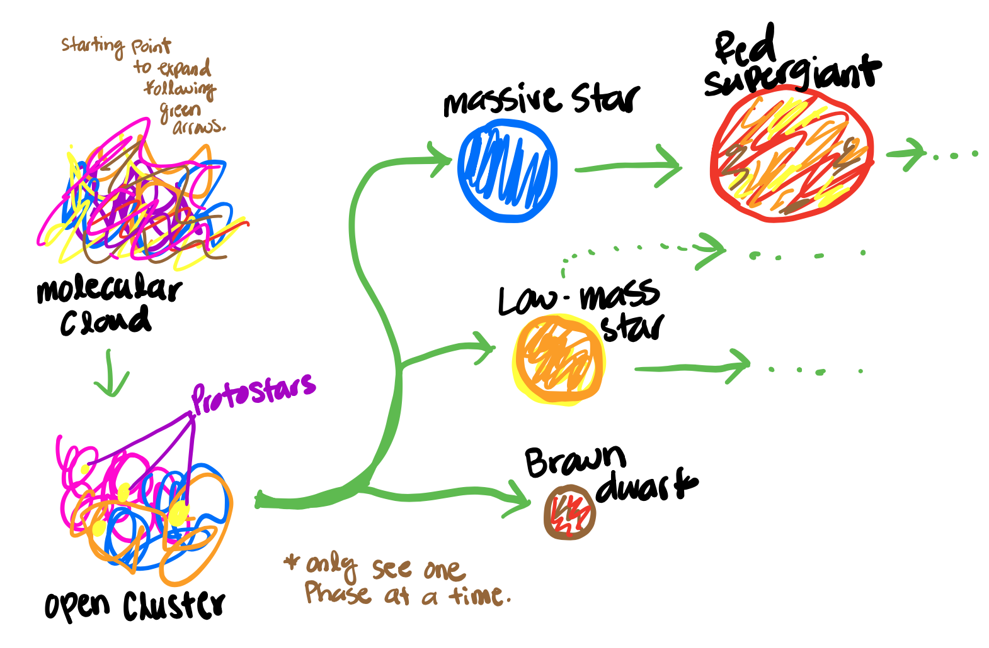

**Figure 2:** Initial sketch of the dynamic Stellar Evolution Tree.

**Figure 3** below shows our next important visualization. Here we plan to create a timeline with a bar that can slide from 0 to 5000 million years. As the user slides through the timeline, they will see where stars of different initial masses navigate through the HR diagram. Users will also be able to click or hover over stars in the HR diagram to learn different characteristics like temperature, mass, radius, and luminosity of stars at that stage.

Lastly, in **Figure 4**, we want to create a 2-D plot, in which users can select different variables for the x and y-axes to see how different stellar properties compare. For example, they may choose to plot temperature against radius, spectral class with mass, and so on.

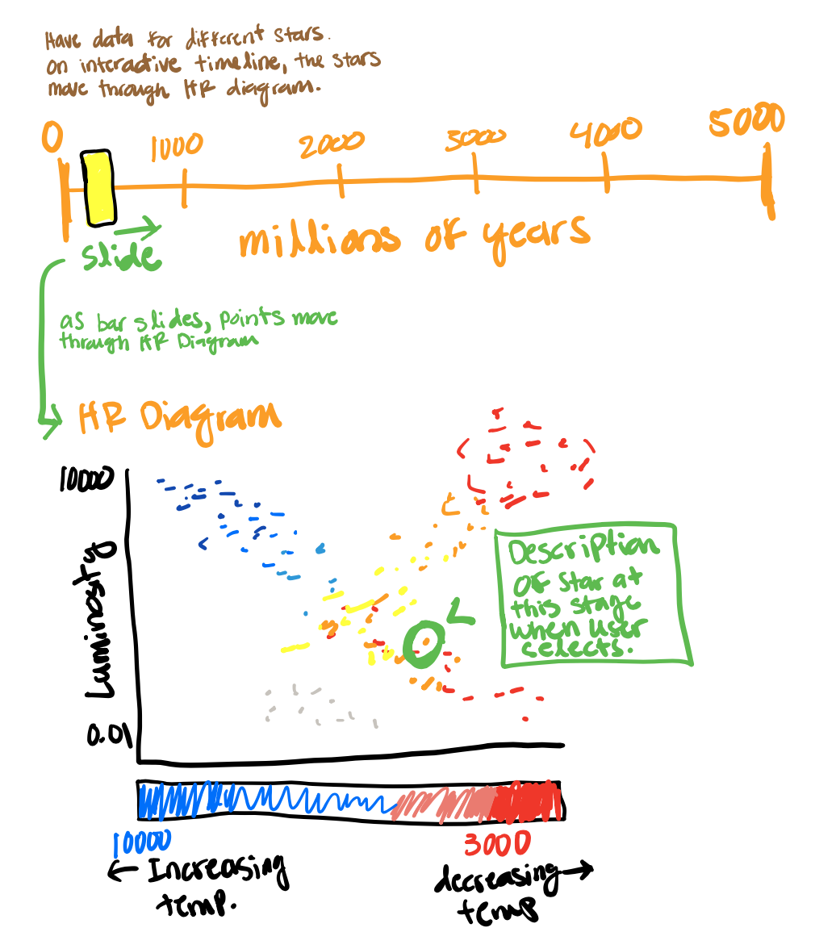

**Figure 3:** Interactive HR diagram sketch. As users slide the pointer on the timeline, they see how the star moves through different regions of the HR diagram.

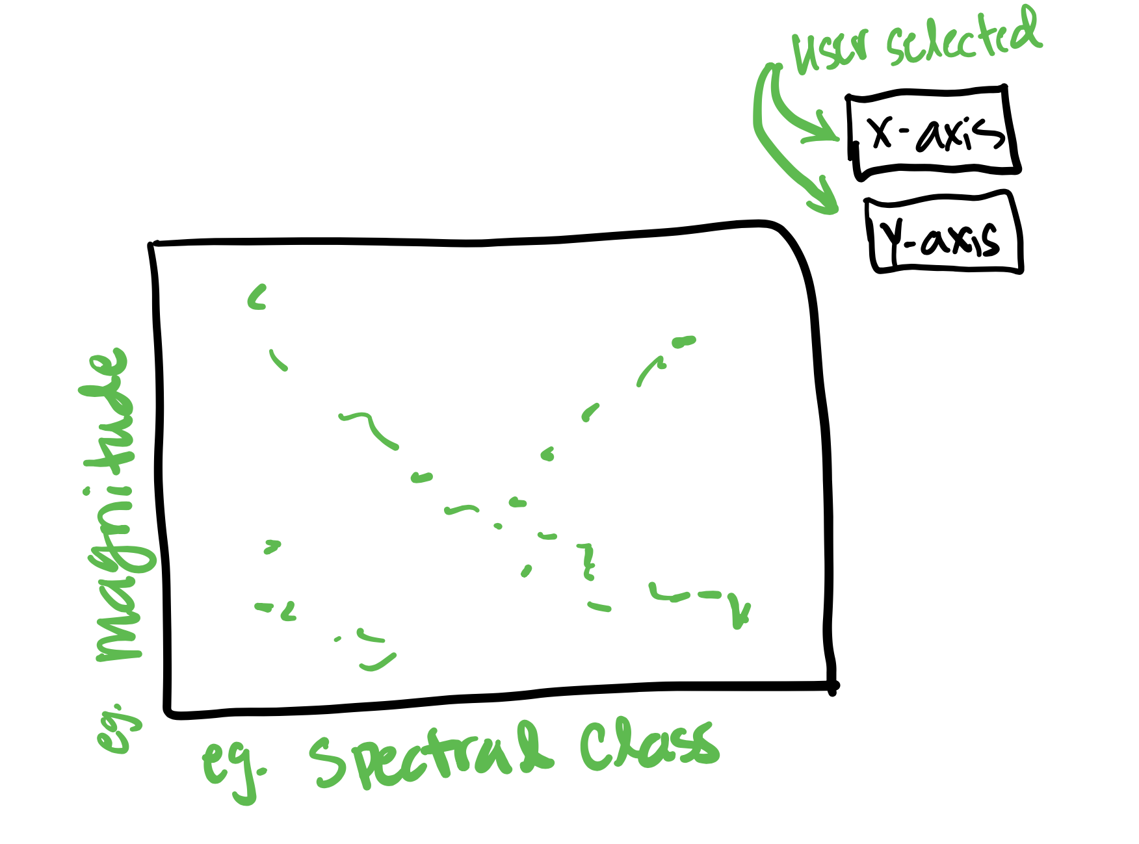

**Figure 4:** Comparative stellar property plot.

Bringing it all together, **Figure 5** shows a tentative plan to arrange the site page.

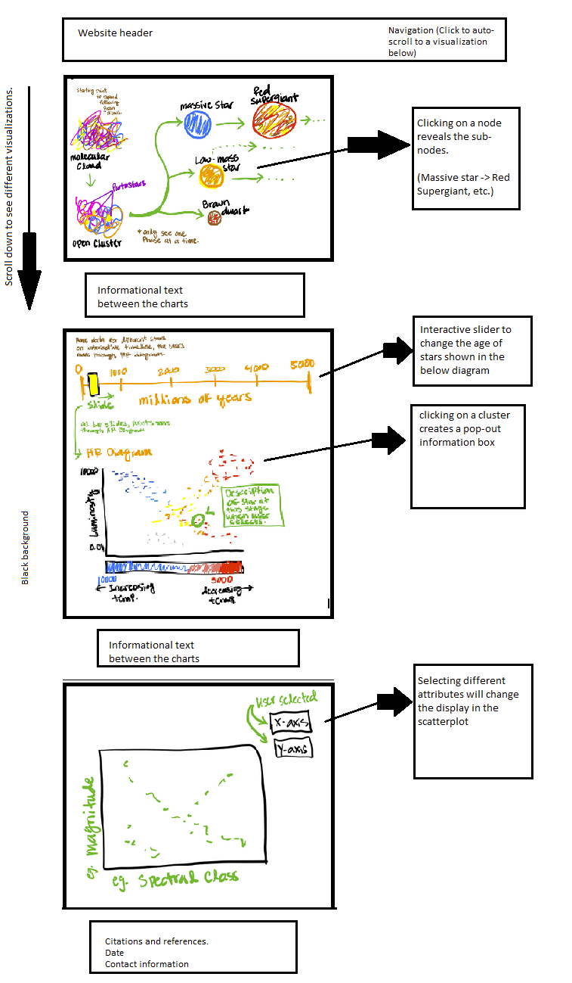

**Figure 5:** Website mock-up.

**Color Pallette**

When we think about palettes, we want to consider the existing heuristics that people *expect* when working with certain kinds of data. For example, earlier we had considered an environmental project where it’s common to use red and green hues for things like temperature and blue hues for humidity/rainfall/water conditions. When we think about astronomical data, the common denominator is presenting data on top of a black field. This makes sense because we see a dark background when we look up at the night sky.

We have considerable leeway for the remaining elements. If we are showcasing individual stars, it might make sense to attempt to show the star’s true color, but when showing a visualization with many stars, that same color becomes less meaningful. High saturation elements tend to pop-out on dark backgrounds, so we want to reserve high saturation for anything that we want to highlight.

For the web page frame and supporting elements, we do not want these elements to distract from the data. A muted palette with simple colors that feature well on a dark background might be best. As a preliminary choice, we are exploring the following:

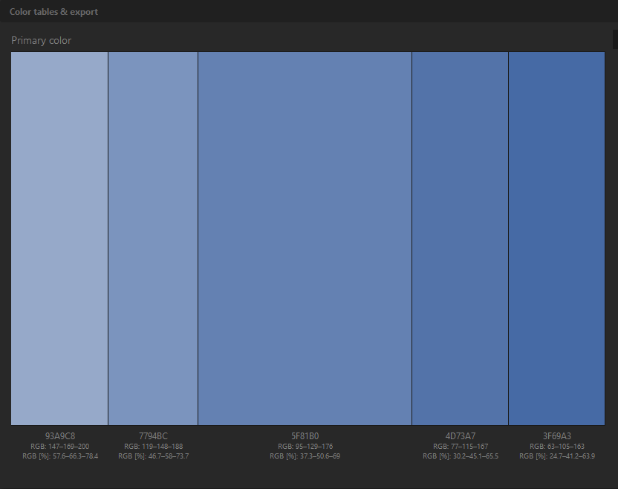

**Figure 5:** Tentative color scheme. Source: [Paletton](http://paletton.com/#uid=13E0p0kg4z59nGYcUCmiTvRltv4)

1. **Must-have Features**

The project must include a stellar-life-cycle chart. This is a great opportunity to showcase tree-based categorical data.

We also want to include an HR diagram. This is a scatter plot of stars showing the relationship between the stars’ luminosities vs their effective temperatures ([Wikipedia](https://en.wikipedia.org/wiki/Hertzsprung%E2%80%93Russell_diagram)). We think that a static two-dimensional representation of this diagram could be improved through animation effects. For example, providing a slider for age in order to show how a star’s position on the diagram is expected to change as it grows older.

We also want to include an interactive chart where users can compare and contrast stellar properties. For example, a user could pick two different stars and see their current age, luminosity, temperature, size, etc. Or, a user could pick one star and see how it compares to the Sun.

1. **Optional Features**

We would like to include clickable objects with transitions to specific data. For example, clicking on a region of the H-R diagram would bring up suitable examples of stars within that range, and then clicking on a star would bring up specific data about that star. Or, in the stellar life-cycle chart, a user could click into a region of the life-cycle, and we provide examples of stars that are currently at that stage of the life-cycle.

1. **Project Schedule**

| **Week** | **Project Objective(s)** | **Notes** |
| --- | --- | --- |
| **September 11th - 15th** | Fetch underlying data and choose the number of target graphics  Complete first iteration of project book |  |
| **September 18th - 22nd** | Clean the supporting Data  Build webpage frame |  |
| **September 25th - 29th** | Finish cleaning the supporting Data and construct preliminary charts  Pick color palette for website & graphics  Build placeholders in the webpage frame for the visualizations |  |
| **October 2nd - 6th** | Iterate on charts and graphs to create final forms of any low complexity elements (i.e. stellar life-cycle chart)  Design the animations and/or scrolling-triggered animations within the webpage frame |  |
| **October 9th - 13th** | Work on high-complexity visualization elements (i.e. animated H-R diagram)  Insert the low-complexity visualizations with the webpage frame & its dynamic components | Fall Break; Rebecca out of office |
| **October 16th - 20th** | Complete high-complexity visualization elements  Write the supporting narrative |  |
| **October 23rd - 27th** | Insert high-complexity visualization elements into the website  Write the supporting narrative |  |
| **October 30th - November 3rd** | Catch-up week | Kevin out-of-town Oct 27th - Nov 4th  **Project Milestone Due** |
| **November 6th - 10th** | Catch-up week  Work on any optional features. For example pop-outs, clickable objects, and transitions |  |
| **November 13th - 17th** | Review and edits |  |
| **November 20th - 24th** | Review and edits |  |
| **November 27th - 28th** | **Final Submission** | **Due November 28th** |